Dubai City Area and House Value

In this project, we are going to see the insights and analytics that we get can able to get from the world’s richest city Dubai about their land values and house sales. Additionally we have option to rentals as well, if anyone plans to stay there.
We are going to analyse the trend and value of a place or area that have been changed over the time.

There are five csv files that we have for this project.
1. area_prices_monthly
2. secondary_sales
3. off_plan
4. rentals
5. metro_stations

area_prices_monthly(csv):
This file contains the information of the areas present in the Dubai. We have monthly trend or rate of value which has changed over a period of time. The notable information are price_per_sqft, metro stations that were available. The key analytics we can find here is that value or worth of areas changes over a month, which directly or indirectly affects the sales and rentals of house.
Off_Plans:
This file contains the details of new house that has been built and being build by various builders organisations. The Builders provide flats or villas across various area and also added the details like price_per_sqft and the payment mode(scheme or plan) that they offer to acquire the house.
Secondary_Sales:
It contains the sales info details of the houses which were already owned by someone, which was being sold or available for sales.
Rentals:
It contains the details of acquiring the house through rental basis(monthly or lease).
Metro_stations:
The metro stations that were located nearby or within the areas and their distance with respect to burj khalifa has also been noted.

Key Insights:
The Burj Khalifa is being considered as a central location. The area’s value or price is directly influenced by this 150 floors building. The more the area is near, more the value is getting increased over a time. I have it has an assumption, lets confirm it through the analysis.

Initial Phase:
At first, I proceed to get initial idea of what present in dataset. So, I imported the files into my databse in SSMS(Sql Server Management Studio) using import the flat file option.
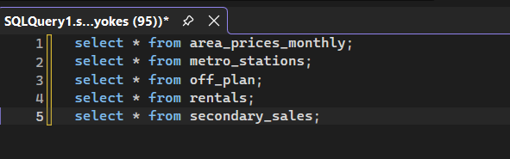
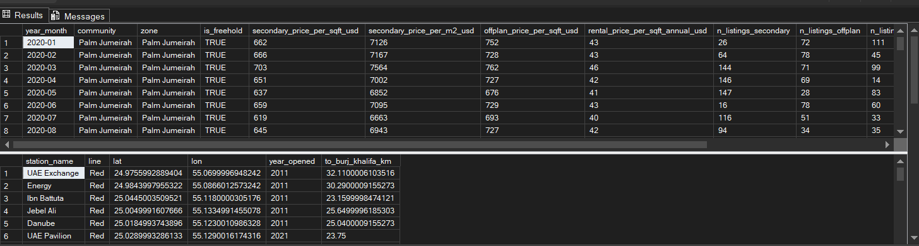
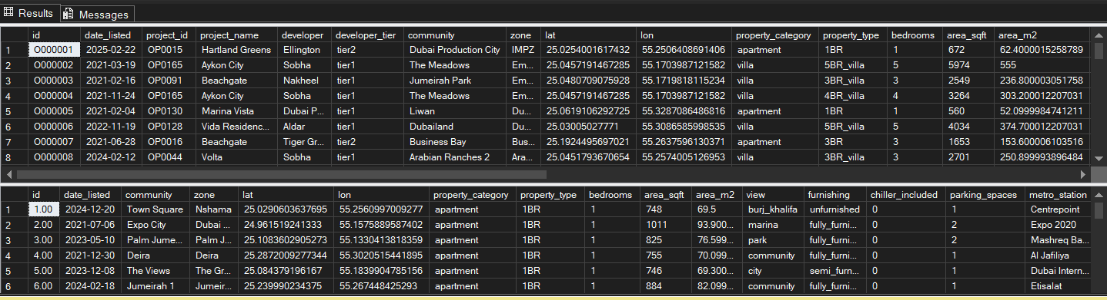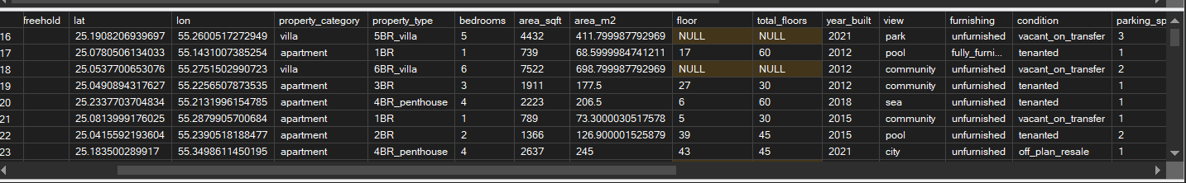

When I viewed their summary, in secondary_sales table I could find the null values in columns floors and total_floors, to detect the count of nulls, I have used the python jupyterlab.
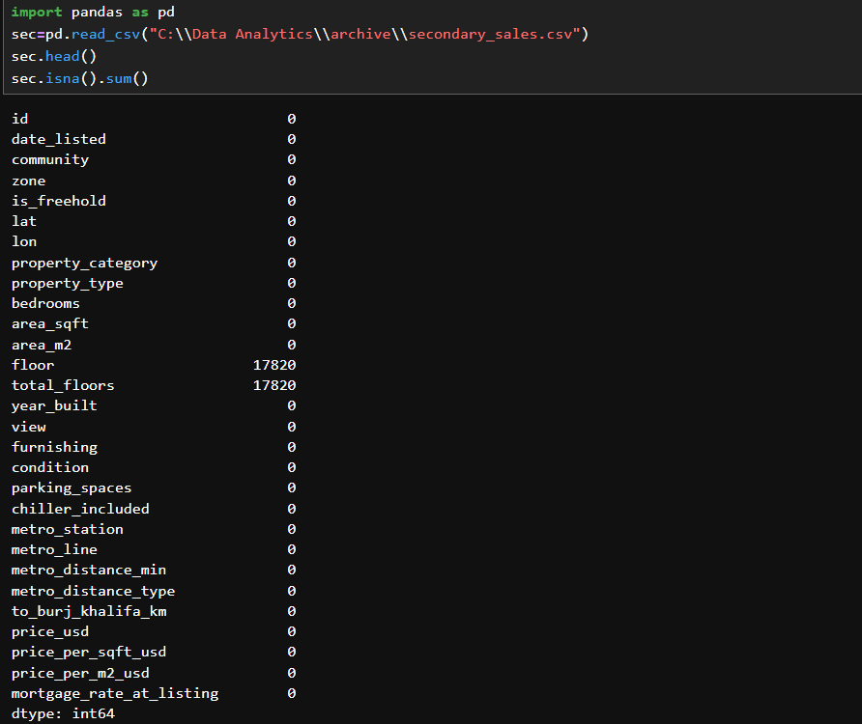
From this, I get o know that there were around 17820 null values present in these columns.
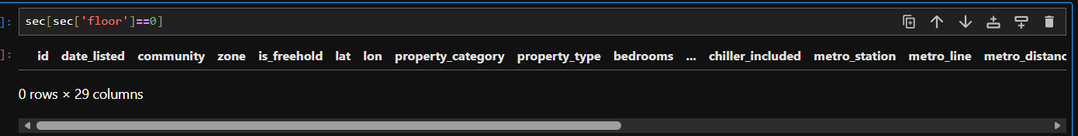
So, I have analyzed the reason for cause, and I found that the house with no floors(0) are considered as null. As the null would affect the quality of output in future, I have decided to replace the null with 0 in both the columns(floors and total_floors).
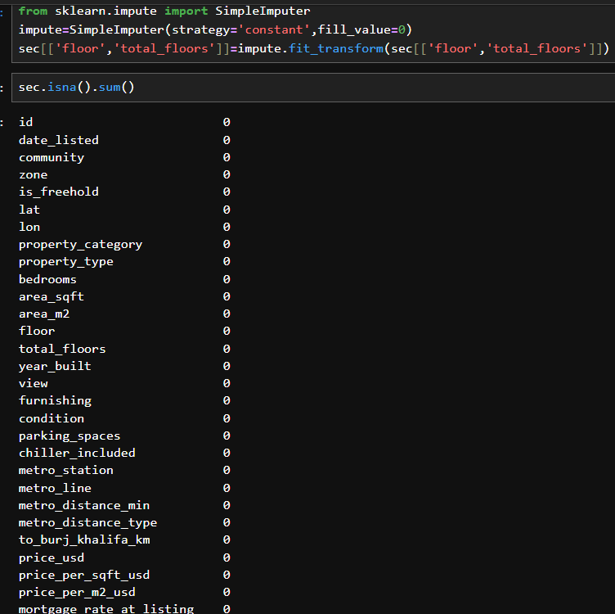
With impute technique, we have replaced the nulls with 0 for those columns. So, we have reloaded the revised file into the SSMS.

Community Analysis:
Initially, I have started to analyze the total no of communities available and count of their offerings(Off_plan,rentals and secondary sales).
After compiling this code, I get to know that there are 84 Communities present in the count of offerings they provide across various categories.

- Among them, Damac Hills 2 community provides the highest number of offerings in secondary sales at a count of 8539 villas.
- Dubai Production City offers the most in off_plans(new house) of 3637 villas.
- Also in rental_house_provider, Dubai Production City provides the highest offerings of around 5549 villas.

In area_price_monthly, I couldn’t find the off_price_monthly values for the certain regions, so considering that I have filled the values t0 0 inplace of regions having null.

I proceed with analyzing the count of rentals and sales over the years and able to find that there was a trend of decrease in count of sales and rentals over the years all the regions(especially in last 3 years).
I doubt that external factors like inflation, war scenarios, long time in initial registration could have lead to this circumstances, we need to analyze more inorder to get the reason for the cause.
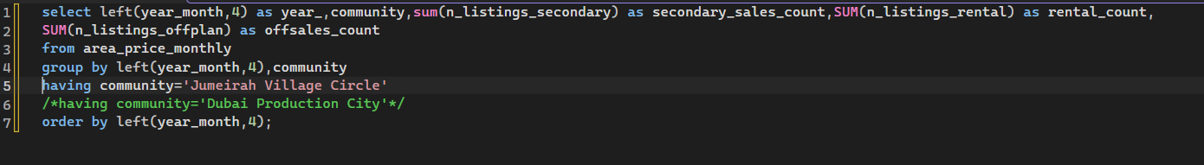
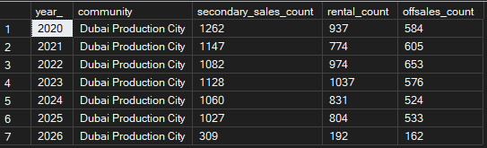
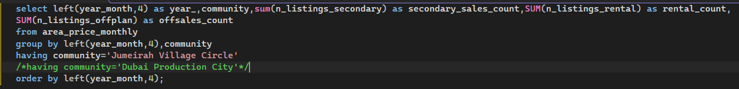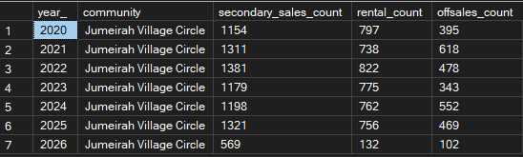

To get more details, lets analyze them in their respective tables(secondary_sales,rentals and off_plans).
Lets, take off_plan table and analyze the insights that we can able to get.
Since, this table contains the information of newly built house, we have column of project builders(developer) the group by which have build the house or villa, to get the information of builders present I used unique() funcytion to know the number of builders wo provides this service.
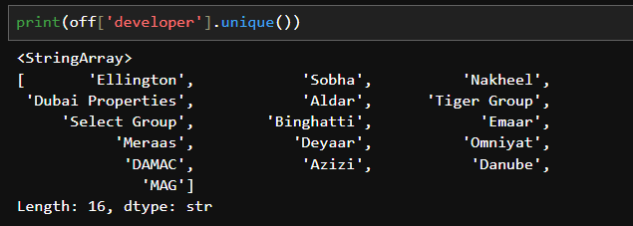
I am able to know that there 16 builders who provide the service.
I have proceeded to know the number of projects handled by these developers and able to know the exact count using count() in python.
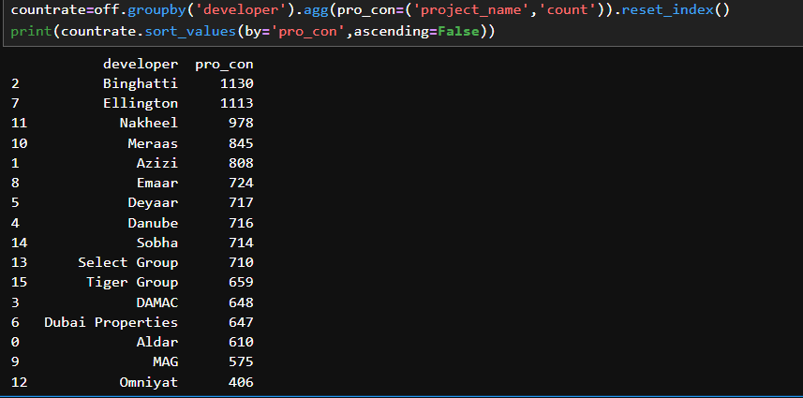
From this, we can understand that Binghatti leads the list of handling 1130 projects and omniyat is the least with handling 406 projects.

In the property_category, there are around 7531 projects comes in apartment category and 4469 in villa(Separate House).(Off_plans).
Rentals:
In rentals, there are around 16000 properties are exist in apartment and remaining are all are separate houses.
The contract basis are of two types:
- Short term
- Yearly
In short term, there are around 2527 plots available and remaining(22473) are all yearly basis.
In short term, there 1663 apartment plots present and remaining are of villas(864).
There are around 84 communities provide plots on short term basis among them Living Legend Community is highest(84). So, people who are all really interested can keep this in mind.
Model to Predict Rental Charge:
I wanted to predict the rental charge per sqft in usd, so I have created a Machine Learning Model with Rental Table. I have implemented it using LinearRegression Algorithm. Purpose choosing this algorithm is the output column is numerical, so I have chosen this. For input features initially I have included the columns like 'property_category','property_type','bedrooms','area_sqft',”parking Spaces’,’chiller-included’ columns as inputs(X). Since the property_category,property_type are of string type, I have changes them to numerical using one-hot encoded technique. When I trained and evaluated them using R2_score metrics I have got score of 0.577252 which is around 58%. So, I decided to check the Features that I have took. I removed ‘Parking_Spaces’ and ‘Chiller_included’ columns from the input. I got still struck with 0.577025 . So, I have included ‘community’column. Then I got the evaluation score of around 81%. I have not stooped with this. I have tested for overfitting as well. When I compared the values of test and train values it was 80.03(in training) and 81.5% in (in test) which is close. Then I came to conclusion that model performs well.
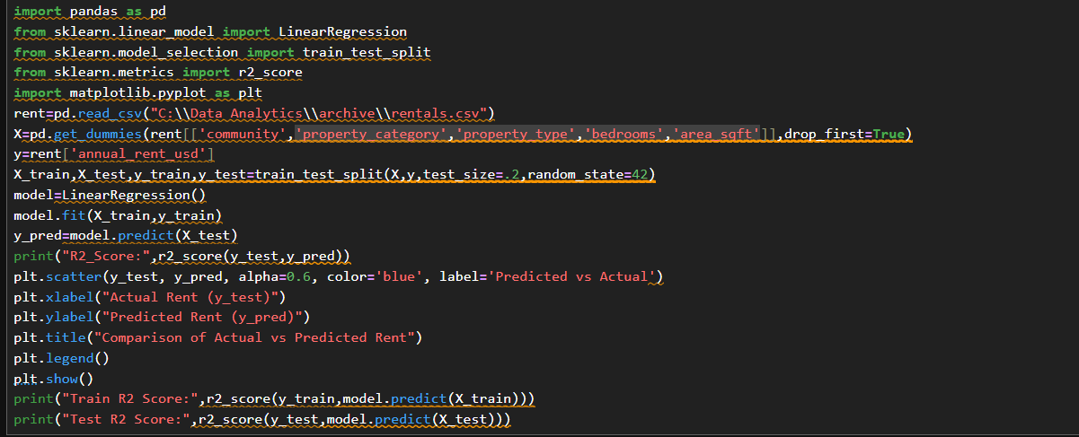
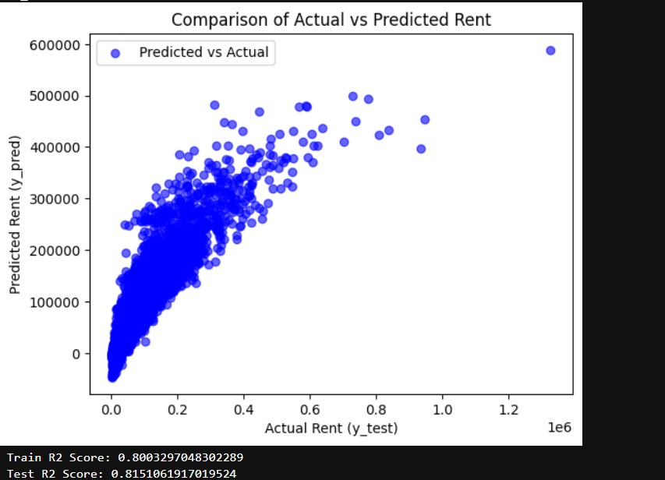

Since, it was my first model built ever, it gives enough confident to proceed further.

Secondary Sales:
The Secondary sales means , the house or villa which comes into sales that was already owned by one or members.
People prefer this, as it offers slightly lesser cost when compared to off_plans.
There are around 52 Zones has Secondary sales in which there are 84 communities sub categorized within zones.
Sales-Condition:
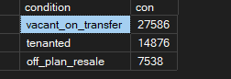
The Property is sold in either of three conditions.
Vacant_on_Transfer: It means, currently it is occupied by people or tenant and when the property is acquired by you, it would be given to you as empty or unoccupied.
Tenanted: It denotes, the people or tenant still lives here on rental or lease basis, you can acquire the property but still they lives there till the rental or lease agreement ends but rental or lease amount will be handed to you till the period ends.
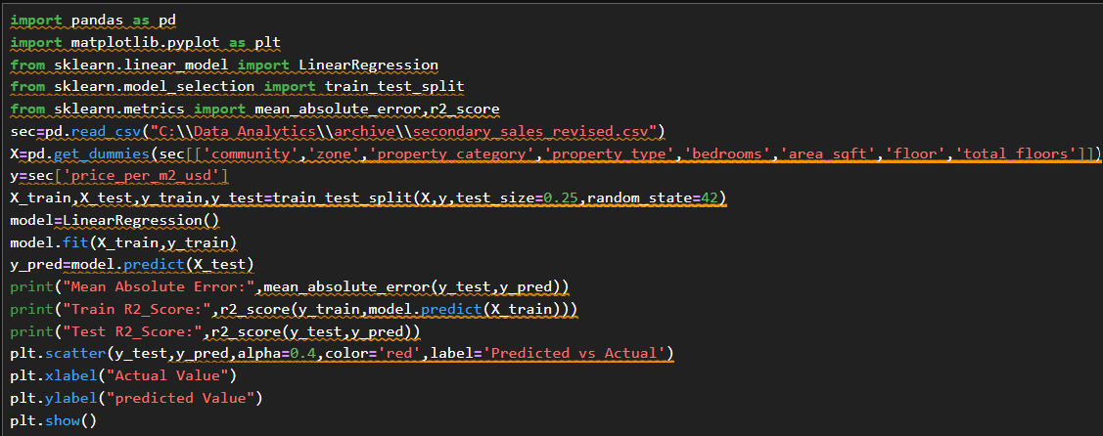
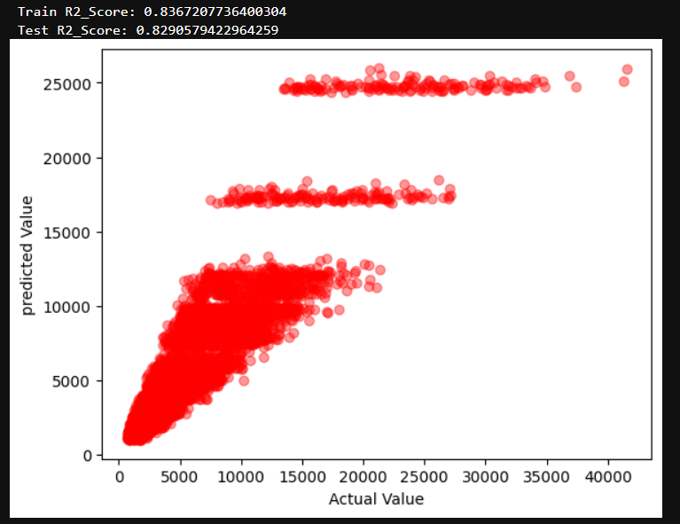
As we did in rentals ,similarly we have created a model to predict the price_per_sqft of the house or below by giving the features like property_category, community and so on.
We have got around the prediction score(r2_score) of 0.829, when we compared with training score the difference is very less and hence we could confirm this model can be used for predicting the price in future.
Year-Wise Analysis:
Secondary_Sales:
When I analyzed through years to know the total sales that have comes into count and we can find a trend like the sales count increases over the years.
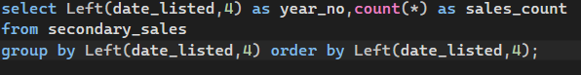
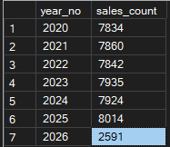
*2026, its only 6 months has passed and still we have 6 months to go. As per our analysis by now (June 2026) we should have reached more than half when compared to last year(more than 4007) but we are seeing only less values(2591). It is due to current war scenario( between Iran and America) as we could witness some attacks in Dubai as well(targeting American Embessey).

Rentals:
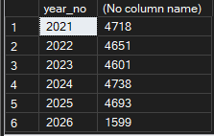
When I analyzed the rentals using similar condition I see variance every year, as we can find that initially(at start) it was high and gradually it got reduced, we could see sudden increase in 2024 and still it got reduced in subsequent years.

Off_plans:
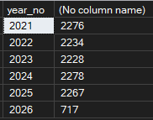
Similar to rentals, we are seeing high availability initially(2022) getting reduced and sudden increase in 2024 and reduction in subsequent years.

When I looked for the count of category available , I have get to know that 1BR sales in off_plans leads the list, as most of the developer prefers these kind of houses especially preferred by the bachelors and small families(Husband and Wife). As they offers low cost, it is preferred over the region.
property_type | Count of Properties
1BR | 2380
2BR | 1933
4BR_villa | 1590
studio | 1392
3BR | 1295
3BR_villa | 1283
5BR_villa | 1110
4BR_penthouse | 531
6BR_villa | 486

PowerBI Report:
The visuals and insights have been demonstrated in PBI report each individually.
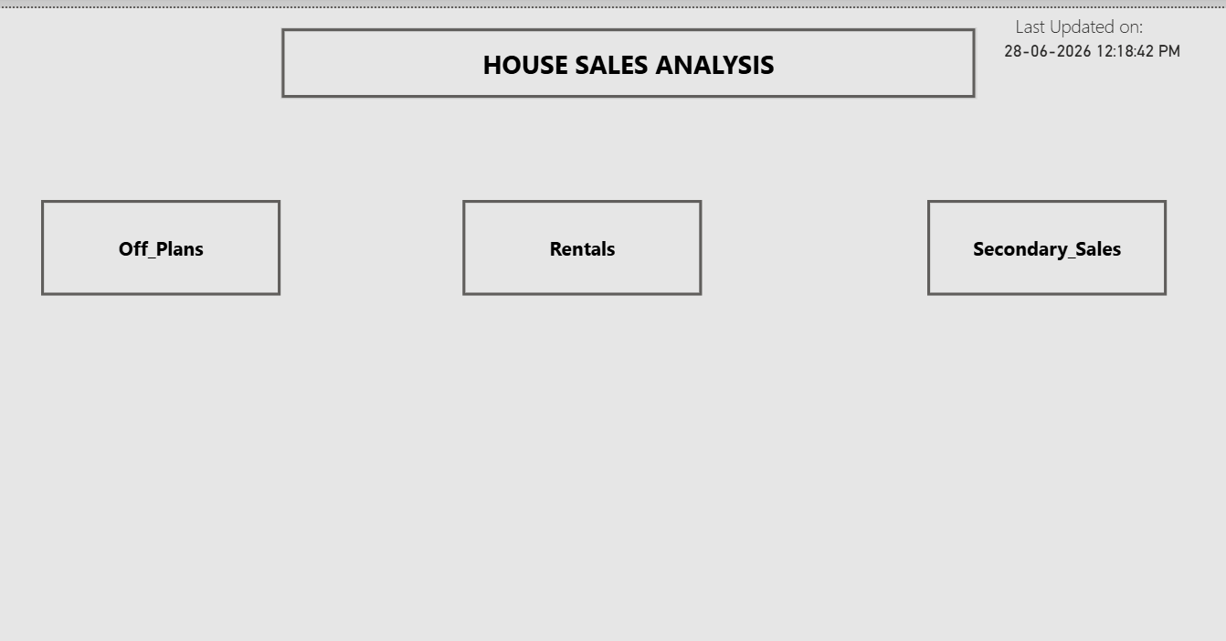
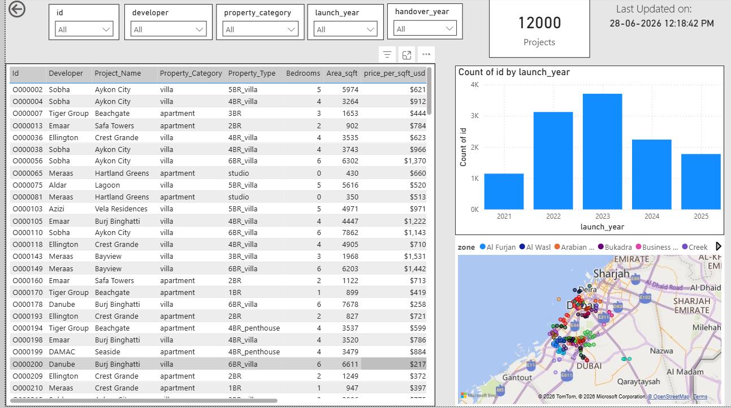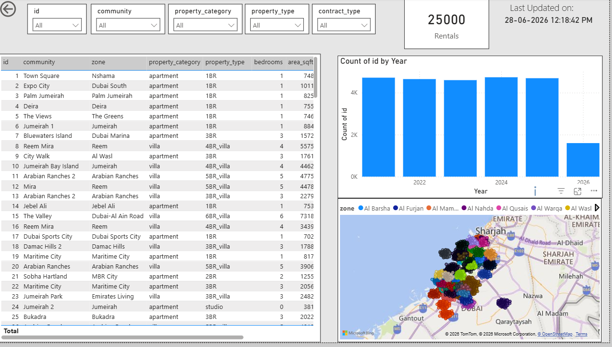
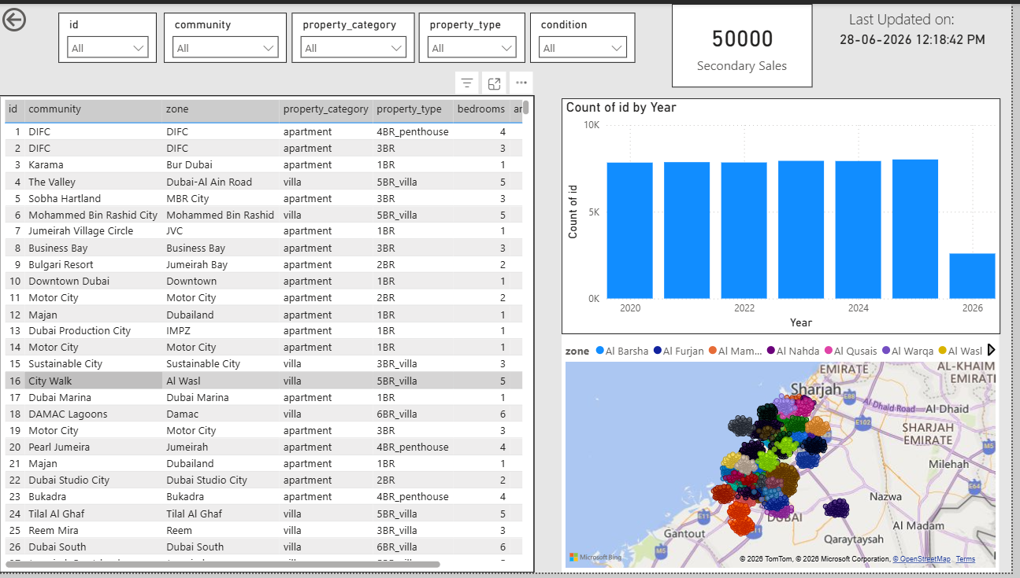
I have tried to create page for Predictive models as well initially, but due to the key column not included and some mismatches in id I couldn’t visualize them as expected, so I would learn it and improve them in upcoming projects.

